Website Design Project Report
Project Name | Blog for Sharp Team
Project Manager | HoaPN
Project Attendees | HoaPN, DucPV, HiepDQ, NhatTQ, CuongNX
Start Date | 26/01/2018
Finish Date | 06/03/2018

1. The objectives
- We do this website because some reason. Firstly, we have to practice HTML, Javascript, CSS for course PRO201, moreover we want to learn Bootstrap, JQuery… Secondly, we want to work together to develop group. Finally, we want to share knowledge of IT for everybody and save beautiful memories of us team.
- There are some problem we need fix: name of class, id sometimes conflict, time make this website is quite long, hard to commercialize,…

2. Key Audiences
We have some the key audiences that you need to appeal to in order to reach your objectives. These are:
- Prospective customers or clients: student, people care for IT, us friend,…
- Existing clients / returning customers: the same above,…
- Members of the press: fanpage of us Club, personal facebook,…
- Prospective employees: everyone.

3. Provisional site structure

Sitemap:
This website have 4 part:
- Home: display 3 article.
- Document: display 3 article, have 1 page to post article.
- About us: introduction us team and tree history my team.
- Images: photo collection of my team.

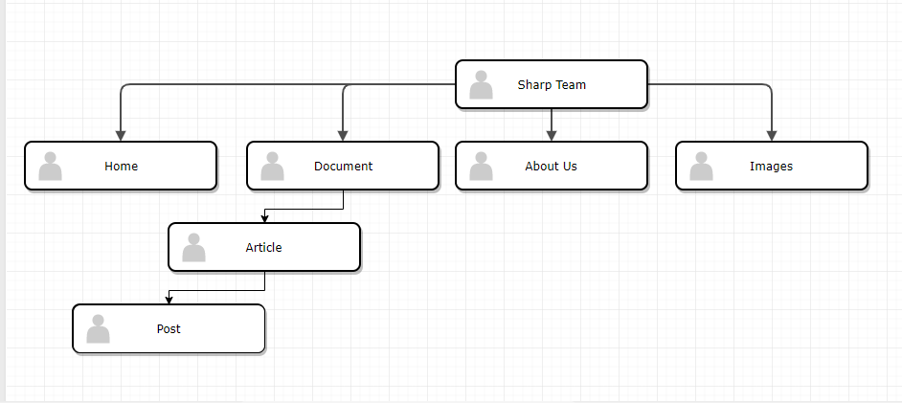

5. Technical specifications
We use multipanel layout.
My website use:
- HTML 5
- CSS
- JavaScript
- JQuery
- Bootstrap 4

6. Websites you like
We design my website.
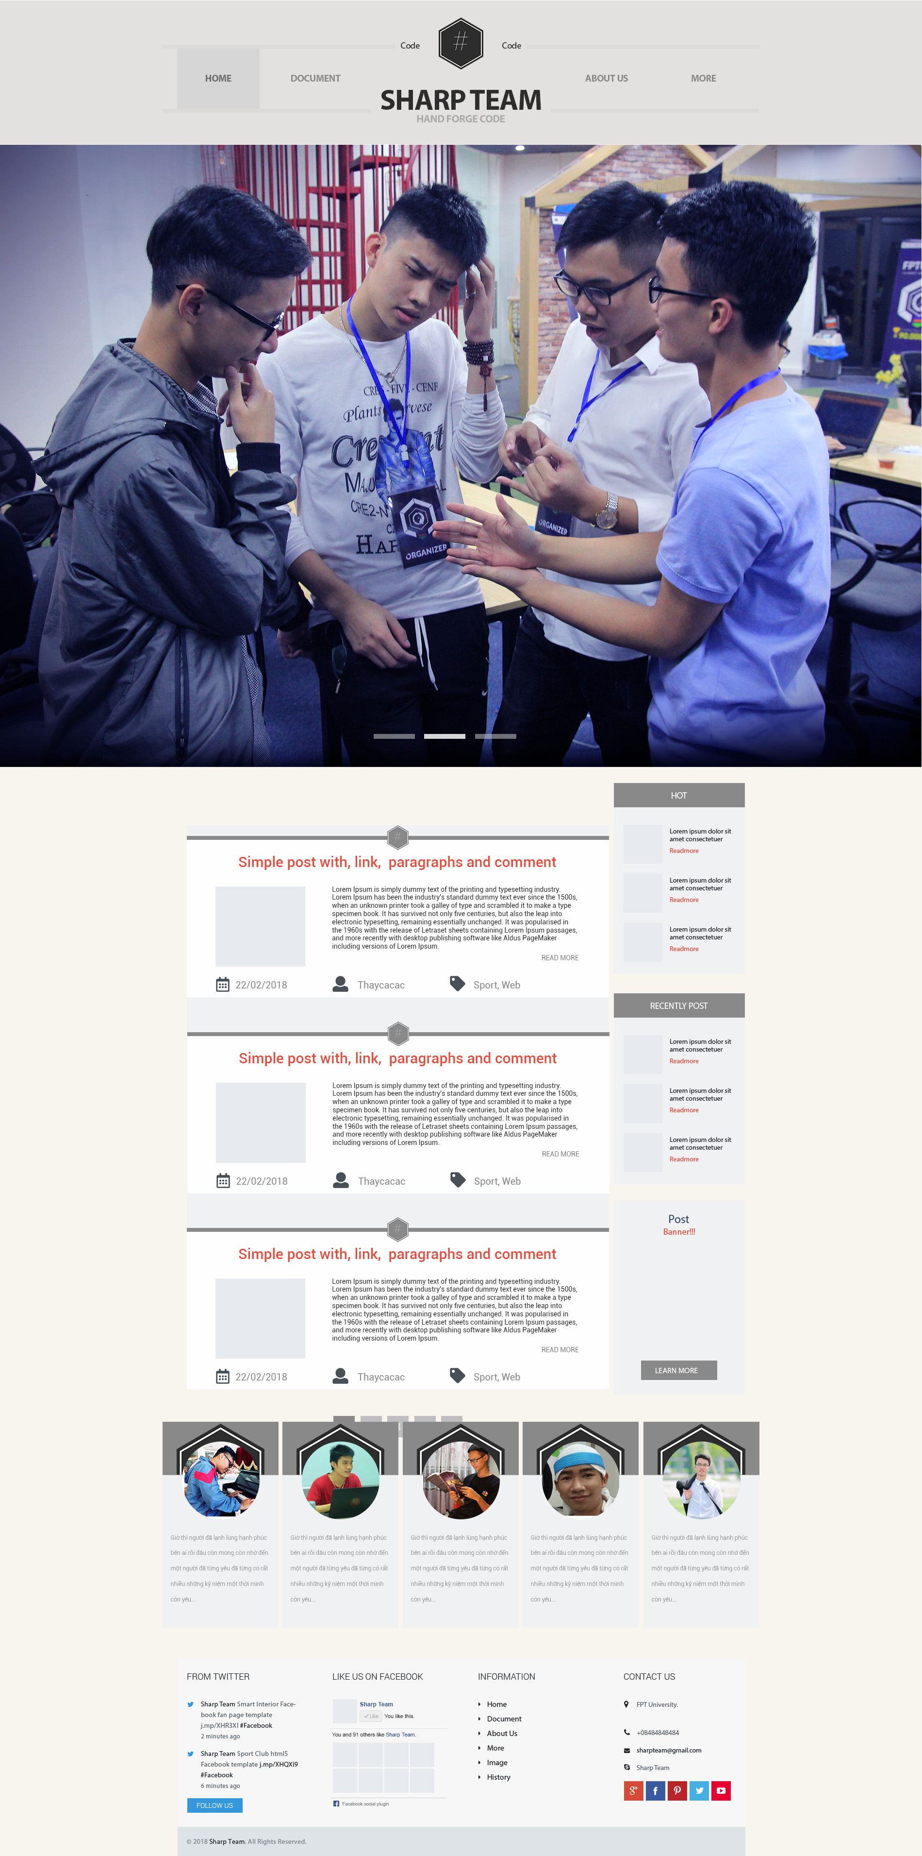

7. Conclusion
We learn so many programing language, learn how to work in group and use tools help merge code. Specially, we feeling happy because we created us website. We will develop this website to it success.

